**ERD and Artefact Requirements**

**Physical ERD**

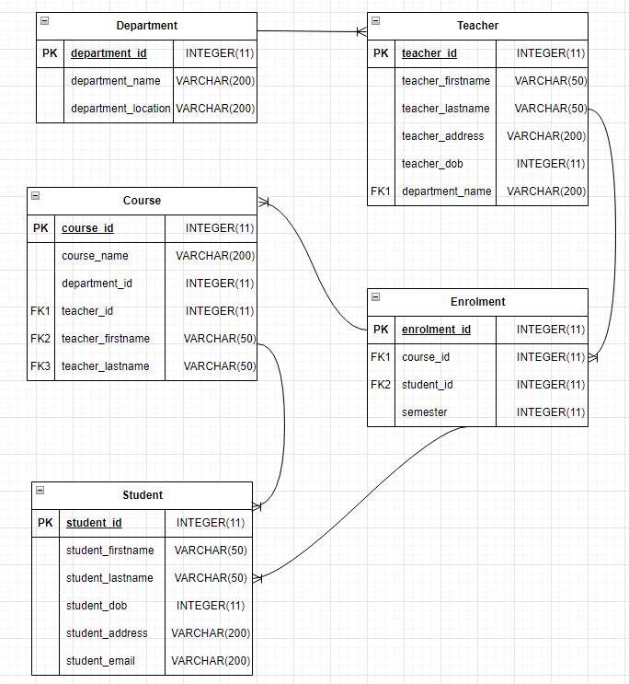

**Logical ERD**

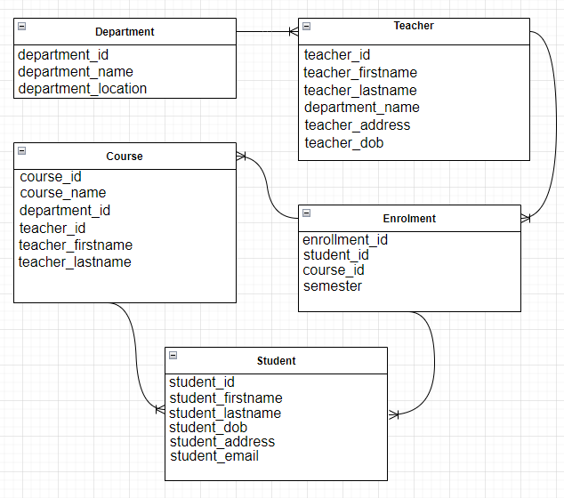

**Conceptual ERD**

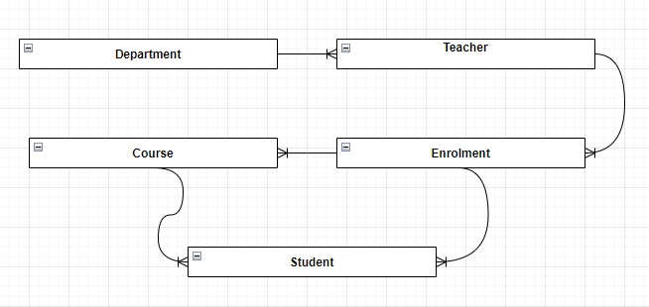

sss